PERMANENT IVV Hiking - 24 Zselic PROOF SHEET


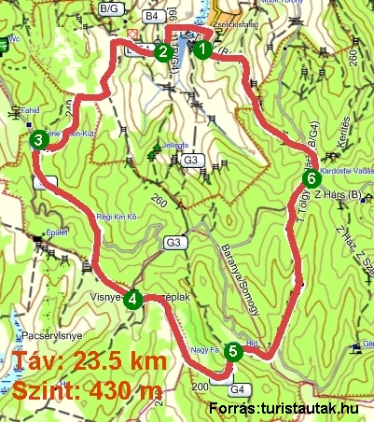

Name:…………………..…………………...……..
Address:.………………..………………….……...

Association:.…………….…………………………
Date:………..………………………………………

Contact:
Szép József
E-mail: mr.szep.jozsef@gmail.com
H-7400 Kaposvár, Honvéd u. 25. 2/1. Phone: + 36 - 30 / 581 - 6353 Kaposvári Természetbarátok TE. http://termeszetbaratok.gportal.hu

1. Zselickisfalud,  VÁNDOR tourist hostel  …………………………….. | 2. Szilvásszentmárton,  wooden statue  …………………………. | 3. Bottomless Well  ……………………………….
4.Visnyeszéplak  …………………………….. | 5.Vitorágpuszta  …………………………….. | 6.Kardosfapuszta,  Hotel  ……………………………..
- Match the migration date marked on the availability of Kaposvár TTE Representative. Annually four times (quarterly) can be met. The 3-digit code number to rotate on a quarterly basis. Kaposvár-distance bus station in the 12-position start 14 flights a day to get one of Zselickisfaludra.
- The green square Zselickisfaludon look for the VÁNDOR tourist hostel, from where the trek starts. Read the 3 digit code on the left side of the entrance of the tree and write. The green square you reach out along the road in a Wild Flower Méhbangó wooden sculpture, works of John Horváth Beres, one of which is protected Zselic flower.
- The Presbyterian Church, go west toward the green square, the road to Szilvásszentmárton into which the Protestant church in front of the wooden statue Fritillary against the code.
- After the shop on the corner, turn right and go up the green square to the bare mountain, he left to follow the green line marking the Zselic Nature Protection Area of the bottomless fountain, where the source signal, you'll find the code. Can fill your water bottle in the cool waters of the forest resource.
- The green bar on lime and beech forest to reach areas crossing Pali outlaw's grave, which made ​​invisible hands regularly with fresh flowers. Visnyeszéplak on the green stripe below the code.
- Go green line marking the now deserted Vitorágpusztá to get just ruined buildings, well branched, bell tower in memory of the ancient times. Vitorágpuszta SE at the end of a beech tree, find the code.
- Following the green line marking the Kardosfa hotel's reception desk is located in the following code, you want it in a little rest and some refreshments consumed.
- From the main road to the left after 300 meters long dirt road you come along Zselickisfalud, replacement of a huge poplar tree hill, thence east-west direction left of the road leading deep historical folk-press house is basement. Continue to go down deep Zselickisfalud way, VÁNDOR tourist hostel, which can be requested accommodation (1 x 2, 1 x 14, 1 x 16 = 32 people) agreement with the above contact person on the website of the tender.
- The pre-agreed manner login with your hand supporting the impression of the seal. The supporting special IVV stamp imprint (stamp payment of the charges in 2013, the 500th - €) ONLY for the purpose of collecting stamp booklet issued request is not possible in any other way, so do not leave home without it! Zselic Recommended hiking map!

