PERMANENT IVV Hiking - 14 Zselic PROOF SHEET



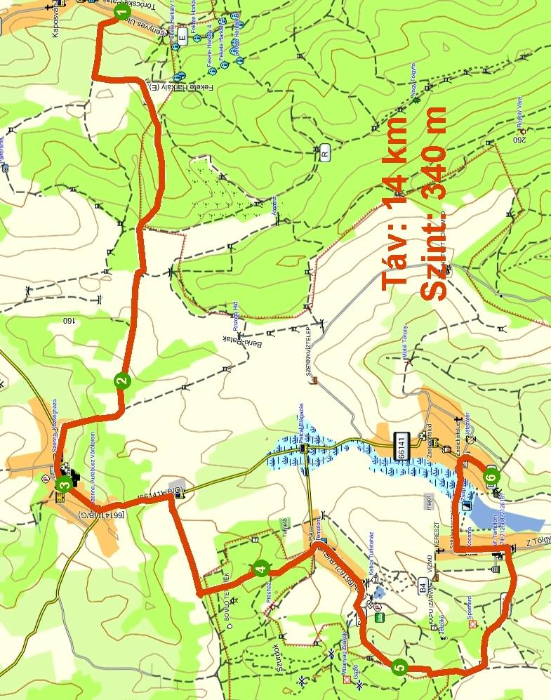

Name:.…………………..…………………...……
Address:….……………..………………….……...
Association:…………….…………………………
Date:…….…….……………………………………

Contact:

Szép József
E-mail: mr.szep.jozsef@gmail.com
H-7400 Kaposvár, Honvéd u. 25. 2/1. Phone: + 36 - 30 / 581 - 6353
http://termeszetbaratok.gportal.hu
Kaposvári Természetbarátok TE

1. Töröcskei,  bus st place  …………………………….. | 2. Treasure Hill  …………………………. | 3. Szenna,  Wood Memorial Museum before  ……………………………….
4. Csipányi Forest  …………………………….. | 5. Nozsi Hill  …………………………….. | 6. Zselickisfalud,  VÁNDOR tourist hostel  ……………………………..

Match the migration time of the contact details on the association's designated representative. Four times a year (quarterly) can be met. The 3-digit code number to rotate on a quarterly basis.
- Vancouver, local bus station to bus 14, 23 flights per day any of the pairs can Töröcskei, round place to go. Here is the code against a red stripe, you will start the trek. Read the 3-digit code number and write. The red stripe along the roof felérsz orchards, they turn to D and 1 km turn right, go to the Zselic Nature Protection Area. - Various parts passing through the forest to get to the ditch Ropolyi valley where the green bar to the right crossing signal, which are you going to west. Berki, cross the bridge and go up the creek Treasure Mountain, which writes the stripe under the code.
- The north end of Treasure Mountain long way down to go deep Senna village. The open-air wooden fence in front of the statue, the green stripe on the code number is displayed. Moving on to the green stripe at the Zselic landscape MGTSZ W went out to do you good dirt road, and forest-Csipányi writes the following code.
- You're going to leave the village and Patca Nozsi Hill writes the following code. Reaching the bare hill east of the green square and down do you go Szilvásszentmárton village, passing through the square on the green Zselickisfalud, VÁNDOR tourist hostel reach the house accommodation which may be required (1 x 2, 1 x 14, 1 x 16 = 32 people) agreement with the above contact person on the website of the tender. Zselickisfaludról 14 flights a day to a few runs Kaposvar bus station.
- The pre-agreed manner login with your hand supporting the impression of the seal. The supporting special IVV stamp imprint (stamp payment of the charges in 2013, the 500th - €) ONLY for the purpose of collecting stamp booklet issued request is not possible in any other way, so do not leave home without it! Zselic Recommended hiking map!

