PERMANENT IVV Hiking - 8 Zselic PROOF SHEET



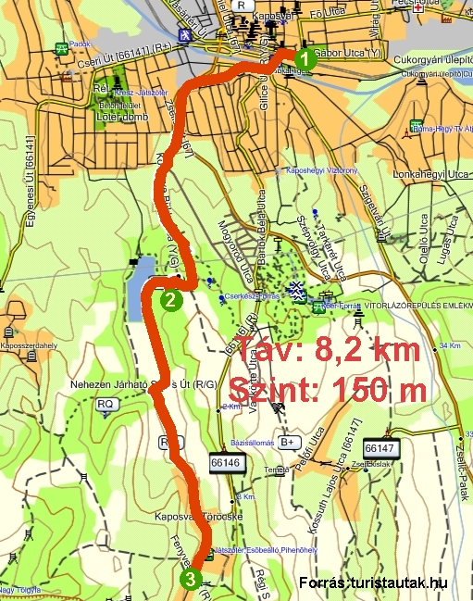

Name:……………..…………………...……..
Address:…………..………………….……….
Association:……….…………………………
Date:..…………………………………………

Contact:
Szép József
E-mail: mr.szep.jozsef@gmail.com H-7400 Kaposvár, Honvéd u. 25. 2/1. Phone: + 36 - 30 / 581 – 6353
Kaposvári Természetbarátok TE. http://termeszetbaratok.gportal.hu

1. Kaposvar,  train station  …………………………….. | 2. Töröcskei Forest Park,  Vackor Farm  …………………………. | 3. Töröcskei,  bus st place  ……………………………….

- Match the migration date marked on the availability of Kaposvar Nature Friends Tourist Association representative. Four times a year (quarterly) can be met. The 3-digit code number to rotate on a quarterly basis.
- Mumbai Railway station in front of the green stripe will start the trek. Read the 3 digit code from the entrance of the east-west direction and write the column. The green stripe along the local bus station in the middle of crossing the railway crossing to the left side, on the overpass and turn left to get to the next Jokai parkland, which is a popular resting place Kaposvár it is a flower bath.
- Go green stripe crossing the Kapos River bridge, then head over to the right side and the shop to the right of you headed to Issa Street, John Street, Rose Street ends right cross the main road and south of keeping the Körtönye Beech Street to get to the Töröcskei friends of Nature forest park with the monument.
- From the red square in Vackor-farmhouse where you get the information written on the board code. Here, you want it a little rest and some refreshments consumed. Return to the red square and a green band warning and Töröcskei Lake to D while you hit the red line marking. In keeping D as part of the city will soon get Töröcskei.
- A hint of Zselic Töröcskei city, at the end of the 14 local bus services at the turn of the red stripe will find the code.
- Töröcskei local bus service 23 rounds per couple travels back Kaposvar bus station, 18 minutes travel time. Tickets can also be a bus driver.
- The pre-coordinated with the supporting mods sign agreements with the IVV stamp for imprinting. The supporting special IVV stamp imprint (stamp fee payment of £ 500.-2013) ONLY for the purpose of collecting stamp booklet issued request is not possible in any other way, so do not leave home without it! Zselic Recommended hiking map!

